['SVU': Kelli Giddish on That Surprise Wedding and Rollins Finding Joy After 12 Seasons (Exclusive)](https://www.etonline.com/svu-kelli-giddish-on-that-surprise-wedding-and-rollins-finding-joy-after-12-seasons-exclusive?amp)

[**Stacy Lambe**](https://www.etonline.com/etonline-staff/stacy-lambe-39)**‍**

11:22 AM PST, December 9, 2022



After 12 seasons on [***Law & Order: Special Victims Unit***](https://www.etonline.com/tv/law-and-order-svu), Det. Amanda Rollins' story came to a heartfelt and emotional close after it [**was revealed**](https://www.etonline.com/kelli-giddish-leaving-law-order-svu-after-12-seasons-189670) at the beginning of season 24 that [**Kelli Giddish**](https://www.etonline.com/people/kelli-giddish) was leaving the NBC crime procedural.

"I think we turned out something that made the fans happy, made me happy and really made sense with the storyline that has gone on," Giddish tells ET, revealing that she worked closely with the writers on "crafting that episode."

"It's always been such a collaborative place, the set of *SVU*. When they told me that Carisi and Rollins were getting married, I knew things were gonna fall into place from there," she continues.

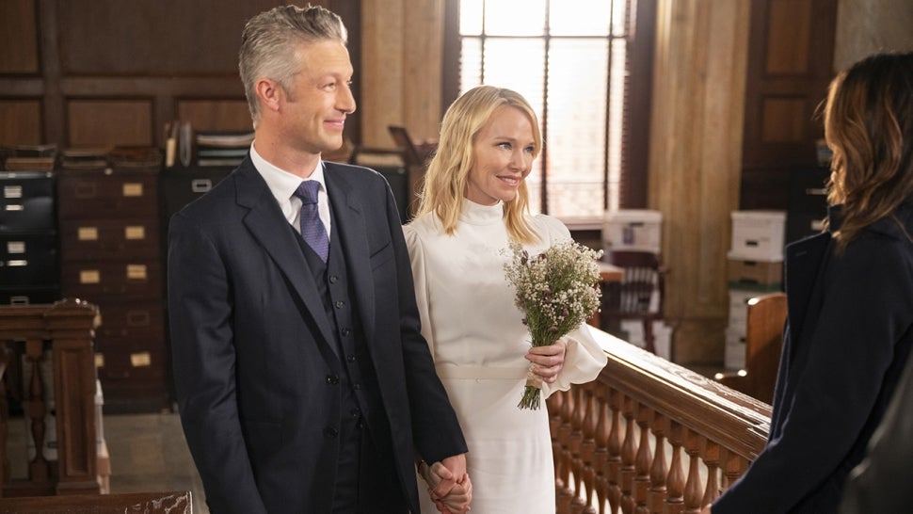

NBC

During the series' midseason, winter finale, "And a Trauma in a Pear Tree," Rollins chose happiness, with the character taking an offer to teach at Fordham University and getting married to ADA Dominick Carisi (Peter Scanavino) during a surprise wedding. Before she leaves the department for good, she has a heart to heart with Capt. Olivia Benson ([**Mariska Hargitay**](https://www.etonline.com/people/mariska-hargitay)) after the two solve one last crime together.

"So much of what we've seen Rollins go through has been so tumultuous, you know," the actress says. "And just to see her go, 'OK, here's something I'm actually really good at. Here's a guy who really loves me and I really love him. Like, let's rest here. Let's kind of explore this and see what stability [feels like]...' It was so emotional."

For Giddish, it was a fitting end for Rollins, who was first introduced in season 13 as one of two new characters alongside Det. Nick Amaro (Danny Pino, who returned for the series' [**500th episode**](https://www.etonline.com/law-order-svu-star-danny-pino-on-returning-for-the-500th-episode-exclusive-174067)) following [**Christopher Meloni**](https://www.etonline.com/people/christopher-meloni)'s unexpected departure as Elliot Stabler at the end of season 12.

A transfer from Atlanta, Georgia, Rollins came from a dysfunctional family, whose visits to New York City always meant some kind of trouble for her, struggled with a gambling addiction and had a child with Lt. Declan Murphy (Donal Logue) before eventually falling into a romantic relationship with Carisi. ("I always loved it when Lindsay Pulsipher came by," Giddish says of the *True Blood* star who played her sister, Kim.)

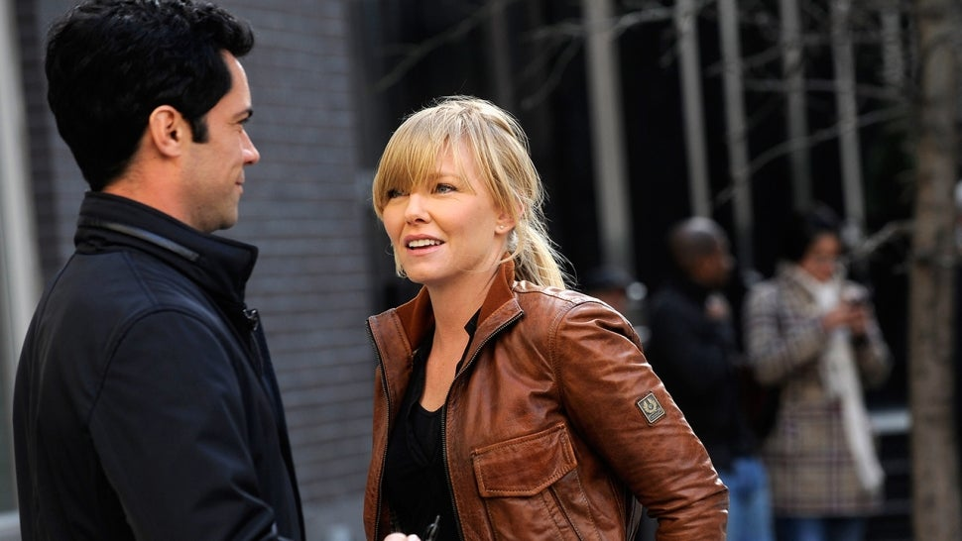

Getty Images

When it comes to Carisi, however, it always felt like the two characters might become romantic, especially after how helpful he always was with her kids. But it wasn't until season 23 that the two officially became a couple, much to the delayed satisfaction of longtime fans.

"The reaction from the fans was crazy. They absolutely went nuts over it," she says, explaining that "it was at a moment, I think it was during COVID, when so many people were lonely and just sad in general. And I think [executive producers] Warren Leight and Julie Martin were like, 'Let's throw everybody a bone.'"

The relationship eventually gathered so much momentum that "they ended up getting married last night, in the final episode."

But Giddish tells ET she had no idea what to expect when things started heading in that direction. "The deep friendship that Peter and I have offscreen and that our families have with each other is kind of reflected in our true and deep respect that we have for each other onscreen," she says. "I think that's reflected in how we handled our relationship even before it was romantic."

While not part of her final episode, the actress' last season did finally give her the chance to work alongside Meloni, who returned to the *Law & Order* universe as the star of [***Organized Crime***](https://www.etonline.com/tv/law-order-organized-crime). While *SVU* and *OC* have [**crossed over**](https://www.etonline.com/law-order-franchise-announces-crossover-event-with-all-three-series-watch-the-teaser-189647) since the latter started in 2021, Giddish and Meloni got to share scenes together when Rollins appeared on the *OC* episode, "Behind Blue Eyes."

It represented a full-circle moment for both the character and actress, bringing those worlds together. "That's exactly how it felt, especially because it was just me and Meloni. I got to have just a two-hander scene with him on his set and I got to feel his energy and his vibe and act with him," Giddish says.

"For so long, he had been this mythical thing," she continues, recalling how she was introduced after he left. "It definitely felt like a full-circle moment and I was really, really happy that we got to have that."

Looking back at her time as Rollins, Giddish remembers what "a rush" it was joining the hit series, especially when other longtime cast members, Dann Florek and Richard Belzer, were still on. "It was crazy," she says. "I just showed up and did my job and tried to develop this character that was really interesting."

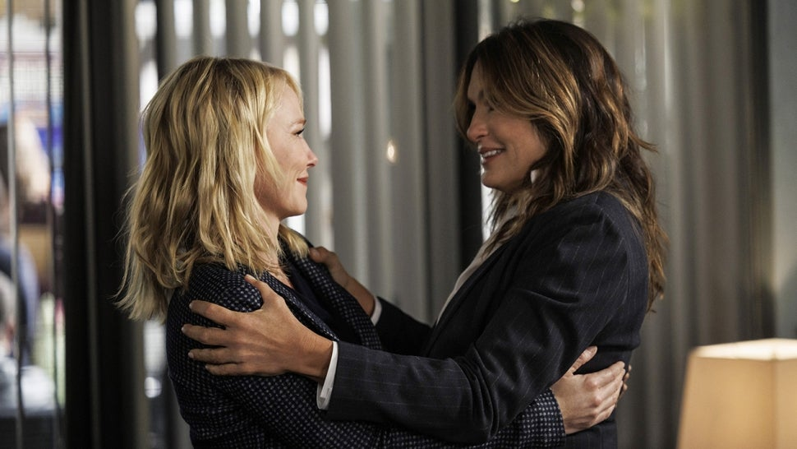

NBC

And now that it's said and done, she hopes Rollins' legacy will be "that she didn't postpone joy," Giddish says. "Rollins went off to not postpone joy anymore… It's really fitting for where the *SVU* world is right now."

Of course, with Rollins married to Carisi and still working in New York City, it's not like she's long gone. So, when asked if she's open to ever returning, Giddish says, "I think the door is always open."

"What's really cool about being on *SVU* is that Dick Wolf created this universe that it's there no matter what and the audience knows and loves all of our characters… So, I think if I popped up somewhere in the future, I think they'd be happy to see me," she concludes.